View in Web Browser

August 15, 2024
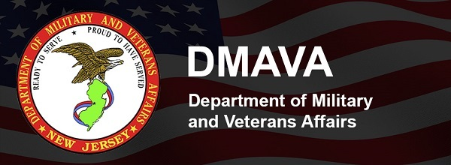
Ready To Serve ★ Proud To Have Served

Commissioner's Corner

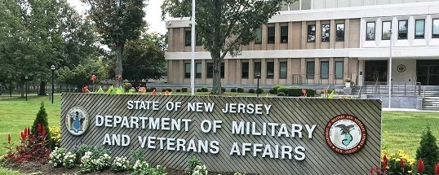

Menlo Park home’s clinical
deficiency-free survey
Last month, the New Jersey Department of Health, acting as agents of the U.S. Centers for Medicare and Medicaid Services (CMS), conducted a no-notice survey, or inspection, of the Menlo Park Veterans Memorial Home. I am pleased to report that the subject matter expects who surveyed all aspects of the home identified zero clinical deficiencies over the course of their nine-day visit.

This is a big deal that confirms the exceptional progress achieved by our team of dedicated healthcare heroes. This win belongs to them. It reflects their deeply held commitment to ensuring the highest possible standards of care for the Veterans, Veteran Spouses, and Gold Star Families who call Menlo Park home. Indeed, the positive results are a testament to their willingness to embrace positive change and implement evidence based best practices.

These on the ground achievements are supported by systemic changes implemented by the N.J. Department of Military and Veterans across the veterans homes at Menlo Park, Paramus, and Vineland. These changes include new electronic medical records systems, a learning management system that has enabled thousands of hours of training and continuing education for direct care and non-direct care staff, and increased wages for frontline healthcare workers to attract and retain the best and most qualified individuals to care for residents.

While the results of the July survey at Menlo Park give us cause to celebrate, I must be clear: no single inspection means that we rest in our efforts to protect our residents’ health and well-being.

Since I assumed my responsibilities in January 2023, our team has been laser-focused on top to bottom improvements to ensure the highest possible care and quality of life at our veterans homes. We are determined to not only meet standards, but exceed them.

As always, thank you for staying connected to DMAVA.

We invite you to share ideas, events and feedback. Please email our team at outreach@dmava.nj.gov.

Vincent Solomeno III
Deputy Commissioner of Veterans Affairs
Administrator of Veterans Affairs

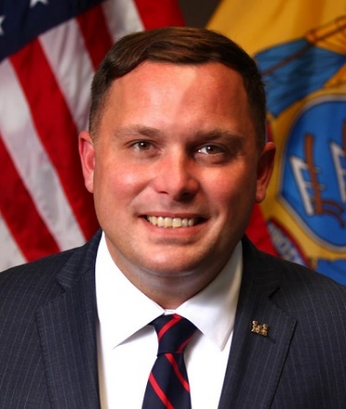

Featured Event



Events

DMAVA Calendar

DMAVA is sponsoring or will participate in the events below. A DMAVA Veterans Service Officer will be present at many of these events. Please check details to confirm.
- August 18 | Bordentown
Reserve & National Guard Transition Benefits Workshop
- August 22 | Teaneck
2024 Aviation Warrant Officer Symposium
- August 23 | Sea Girt
Book Talk: Killing Shore – The True Story of Hitler’s U-Boats Off the New Jersey Coast
- August 26 | Morris Plains
Morris County Veteran Appreciation Day
- August 29 | Point Pleasant
Veterans Outreach Campaign
- August 29 | Columbus
Veterans Outreach Campaign
- September 7 | Bordentown
Military Transition / Retirement Seminar
- September 7 | Tinton Falls
Veteran Resource Fair

Community Calendar

We add new events to our calendar on a daily basis so please bookmark and check back often.
View Full Calendar

Spotlight

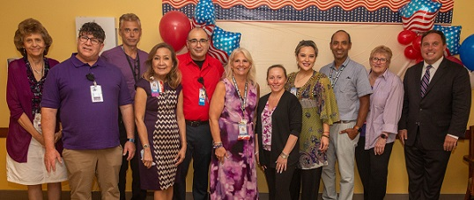

Big Win for Menlo Park
DMAVA News Release | August 15, 2024

Menlo Park, N.J. – The New Jersey Veterans Memorial Home at Menlo Park received no clinical deficiencies for the no-notice survey, or inspection, conducted by the New Jersey Department of Health on behalf of the U.S. Centers for Medicare and Medicaid Services from July 8-16, 2024. Menlo Park is one of three long-term care facilities operated by the N.J. Department of Military and Veterans Affairs.

“We will not stop striving to provide the residents of Menlo Park with the highest possible quality of life and care,” said Lisa Kranis, Chief Executive Officer of the Menlo Park home.

“I am proud of the dedicated team at Menlo Park for the hard work they do every day, and all that they have done to continuously improve care for our residents,” said U.S. Air Force Col. Yvonne L. Mays, Acting Commissioner of Veterans Affairs and Adjutant General of New Jersey. “These findings support all of that hard work across the home, especially their accomplishments over the last eighteen months.”

The survey was comprehensive and encompassed everything from the home’s infection control and clinical care to kitchen operations, human resources, emergency management, and housekeeping.

“Our team is laser-focused on top-to-bottom improvements to ensure the highest possible care and quality of life at our Veterans homes. We are determined to not only meet standards, but exceed them,” said Vincent Solomeno, Deputy Commissioner of Veterans Affairs and Administrator of Veterans Affairs.
Full News Release

NJ National Guard

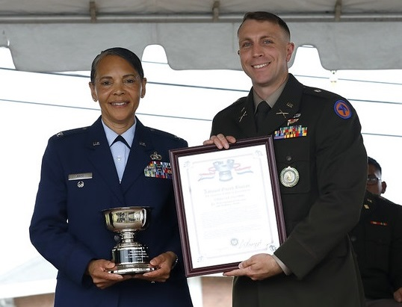

2024 NJARNG OCS Graduation
Sixteen Officer Candidates graduated from the New Jersey Army National Guard Officer Candidate School at a ceremony held at the National Guard Training Center in Sea Girt, NJ on August 4, 2024.

The ceremony was overseen by the leadership of the New Jersey National Guard and is the end of an 18-month training schedule to commission as officers in the Jersey Guard.
View Images

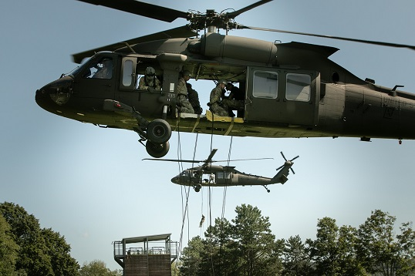

1-150th Aviation Regiment
Soldiers with the 1st Battalion, 150th Aviation Regiment, New Jersey Army National Guard conducted air assault training with Cadets at the U.S. Military Academy, West Point, New York on July 27, 2024.

This training highlights partnered operations involving USMA, Sabalauski Air Assault School of Fort Campbell, KY, and the New Jersey Army National Guard, which collaborated to host the Air Assault School at the Academy.
View Images

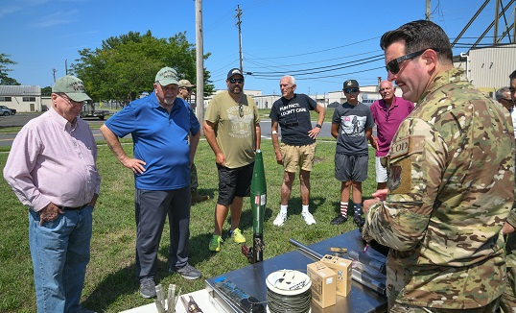

177th Fighter Wing
Recently, 177th Fighter Wing Vietnam veterans visited the base for a tour.

Their tour included a briefing by the 177th Fighter Wing commander Col. Derek Routt, an F-16 display, a showcase of aircrew flight equipment, an overview of explosive ordinance disposal team tools, the firefighters’ tools, and finally "The Brig" in which the veterans saw pictures of themselves in the base records.

Thank you to the brave Airmen who served the 177th Fighter Wing during the Vietnam War, it was a pleasure to give them this base tour.

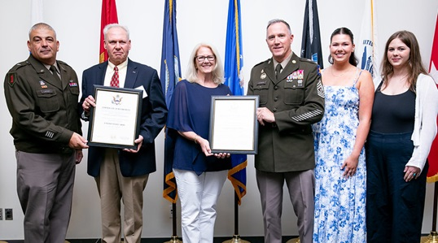

Final Formation
U.S. Army Brig. Gen. L. Mike LaPoint, Assistant Adjutant General – Army, and Command Sgt. Maj. Mark A. Leonard, the State Command Sergeant Major of the New Jersey National Guard, hold a Last Formation ceremony at the Bordentown Armory on August 10, 2024.

The Last Formation ceremony recognizes Soldiers and their families who are departing or starting a much-deserved retirement from military service.
View Images

Join Our Team
100% Free College Tuition
Bonuses up to $20,000
Student Loan Repayment

  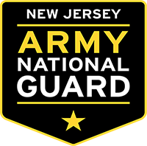
  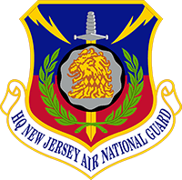

DMAVA Veterans Services

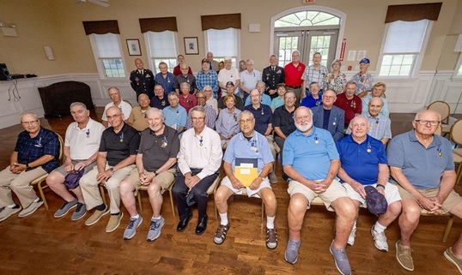

State Medal Ceremony
The New Jersey Department of Military and Veterans Affairs held a state medal ceremony at the Four Seasons in Galloway, NJ on August 12, 2024.
View Images

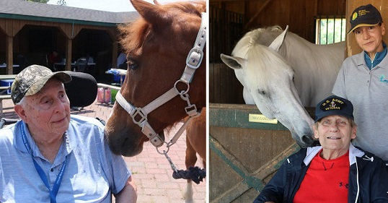

Veterans Home at Paramus
Recently, residents of the Veterans Home at Paramus visited the Bergen County Equestrian Center.
View Images

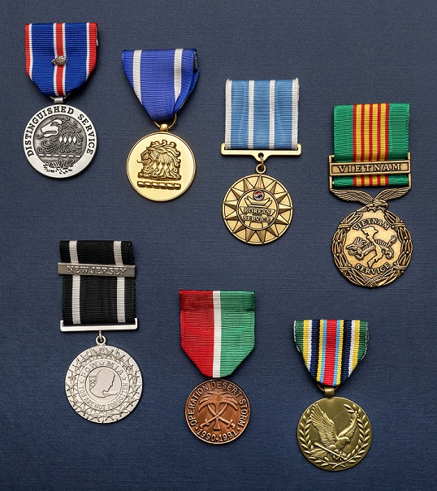

NJ Service Medals
The State of New Jersey awards medals to honorably discharged Veterans of the state who served in various conflicts and combat theaters.

State medals include the Distinguished Service Medal, Meritorious Service Medal, Korean Service Medal, Vietnam Service Medal, POW/MIA Medal, Desert Storm Medal, and the Global War on Terrorism Medal.
Learn More

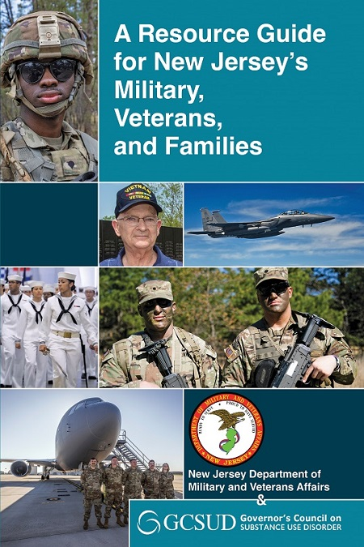

The Resource Guide has been updated effective July 25, 2024.
Get Current Edition

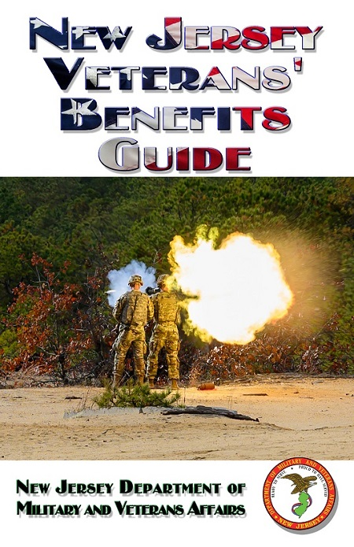

The Benefits Guide has been updated effective July 23, 2024.
Get Current Edition



SMS Alerts - Text "NJVets" to 78015
Opt-in now to receive SMS Alerts from DMAVA! Text "NJVets" to 78015 or scan the QR code above and send. You will be immediately opted-in to receive alerts and important messages from the Division of Veterans Services.

This service is provided free of charge, however, carrier messaging and data rates may apply. To opt-out at any time, simply reply “Stop”.

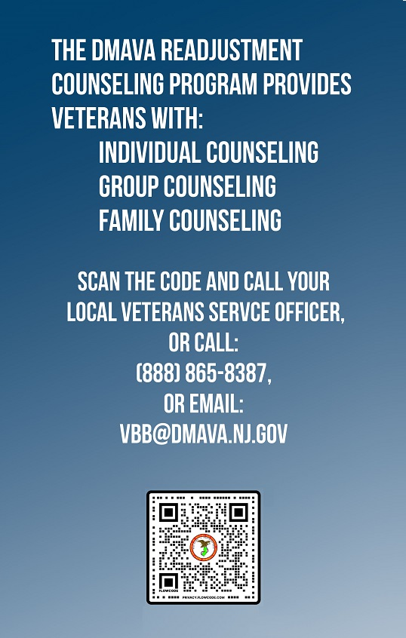

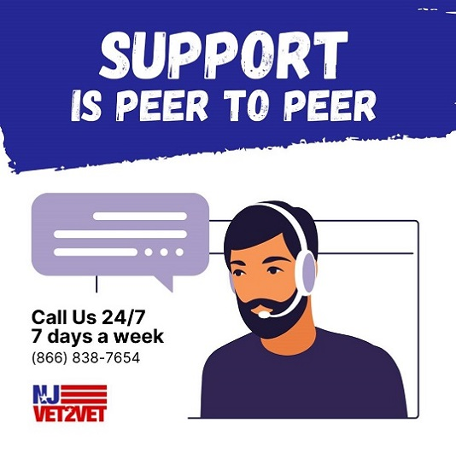

NJ Veterans' Benefits Hotline

888-865-8387

vbb@dmava.nj.gov
Veterans Outreach Schedule
Veterans Service Offices

DMAVA Departments

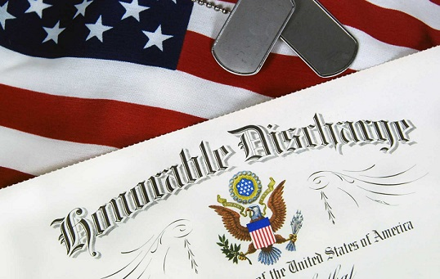

Office of Records and Archives
DMAVA’s Administrative Services Division’s Office of Records and Archives is the office that receives military discharges from the Army, Marine Corps, Navy, Air Force, Space Force, Coast Guard, and occasionally, the Merchant Marines. This applies to both the Active Duty and their Reserves, to include the National Guard.

The DMAVA employees of the Records and Archives Office are some of the busiest people within the Department. They are responsible for the archiving, storage and issuance of copies of military records of all the State’s service members and Veterans.
For more information, visit our website at Request Military Records.

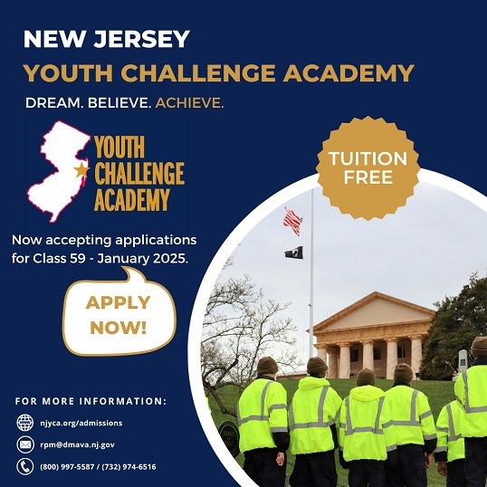

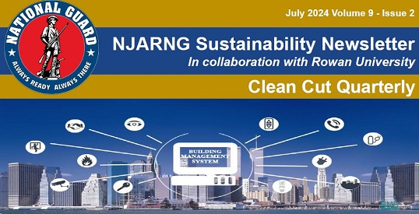

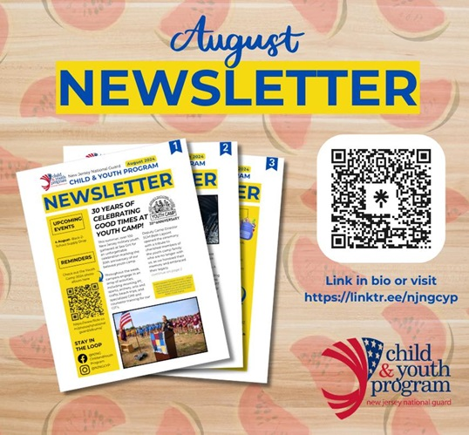


Office of Diversity, Equity, Inclusion and Belonging
DEIB Newsletter

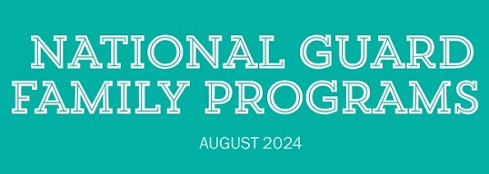
August Newsletter

State Partners



NJ State Agencies

- Governor's Challenge to Prevent Suicides among Service Members, Veterans & Their Families
- The New Jersey's Governor "We Value Our Veterans" Awards
- Vote For Valor
- Career Services for Veterans
- Tax Resources for Military/Veterans
- Educator Certification for Military Spouses and Veterans
- Civil Service Preference for Veterans
- NJ National Guard Hunting / Fishing Licenses
- NJ Special Hawker and Peddlers License
- Veterans Designation for Drivers License
- Military CDL Skills Waiver Program
- Disabled Veteran / Purple Heart Recipient Placards
- Disabled Veteran Hunting and Fishing Licenses
- Veteran and Disabled Veteran-Owned Business
- Division of Consumer Affairs Military Outreach & Support
- Professional & Occupational Licenses for Veterans and Spouses
- Military and Overseas Voting
- Troops to Teachers
- Journey Through Jersey

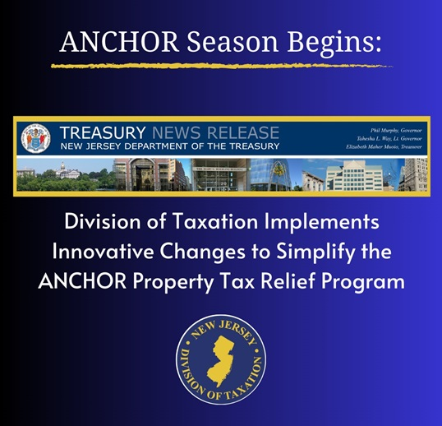

ANCHOR Season Begins: A Record 1.5 Million New Jerseyans to Receive Automatic ANCHOR Payments
August 13, 2024 | News Release Excerpts

(TRENTON) - Treasury's Division of Taxation will officially kick off the upcoming season of the popular ANCHOR property tax relief program next week, when it will begin mailing letters to about 1.5 million New Jerseyans to confirm their automatic eligibility for this season's benefit. The Division has also implemented a number of changes this season designed to further simplify the application process for new applicants and improve taxpayer experience.

Continuing the streamlined application system implemented last season, the Division of Taxation will file applications automatically on behalf of most homeowners and renters who previously received an ANCHOR benefit. Beginning August 19, the Division will mail ANCHOR Benefit Confirmation Letters to approximately 1.5 million taxpayers to notify them that their application will be filed automatically.

If the personal information listed in the letter (name, mailing address, and banking information if their benefit was distributed via direct deposit) has changed since their last ANCHOR payment, taxpayers will need to file a new application by September 15, 2024 by visiting anchor.nj.gov.

All payments will be issued on a rolling basis beginning in November. The deadline to file an application is November 30, 2024.

With the goal to reach eligible homeowners and renters who have not previously applied, the Division will send ANCHOR Application Mailers with information on how to apply for the program to over two million residences beginning August 26.
Read Full News Release

Federal Partners

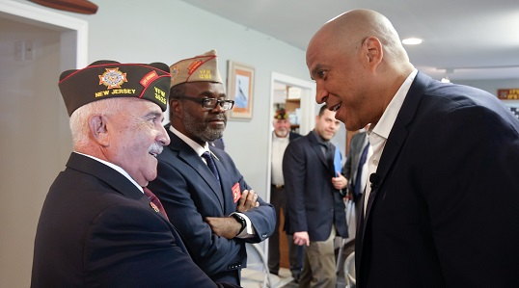

From U.S. Senator Cory Booker
On the fourth day of his 2024 summer road trip, U.S. Senator Cory Booker (D-NJ) visited Veterans of Foreign Wars Post 12173 in Little Egg Harbor to announce three Congressionally Directed Spending (CDS) awards he secured for New Jersey Veterans.

“Our veterans have sacrificed everything for our country, and it’s our duty to ensure they have access to the resources and support they need,” said Senator Booker. “I am proud to have secured these three CDS awards for New Jersey’s veterans. These investments will expand mental health services and outreach efforts so we can ensure no veteran in Jersey is left behind, and will help to strengthen diverse small businesses in New Jersey, to include veteran-owned businesses.”

The New Jersey Veterans of Foreign Wars (NJVFW) is set to receive two CDS awards in federal fiscal year 2025 totaling $547K to establish a disenfranchised veterans mental health and outreach program. These awards will enable NJVFW to expand its mental wellness program for New Jersey’s 338,000 veterans by increasing social worker and case management capabilities, by funding increased peer to peer programming and mental wellness retreats, and by expanding outreach to disadvantaged veterans through the purchase of two electric vans.

The third CDS award is an allocation of $600K to the New Jersey State Veterans Chamber of Commerce to establish an online platform for disadvantaged and diverse small businesses. This award will allow the chamber to develop an online platform that allows the state and private sector business community to buy first from diverse businesses, to include veterans, disabled veterans, military spouses, women, and minority owned businesses.

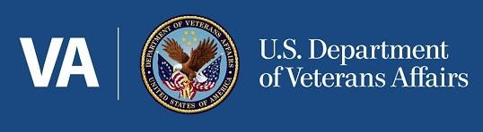

VA Redesigns and Expands Burn Pit Registry
VA News | August 1, 2024

VA today announced the launch of the redesigned Airborne Hazards and Open Burn Pit Registry (“the Burn Pit Registry” or “the registry”). The Burn Pit Registry is a database that combines Veteran and service member data to help VA better understand, research, and ultimately improve treatment for the health challenges faced by Veterans exposed to airborne hazards and burn pits during their military service.

It’s important to note that participating in the registry does not have an impact on your VA health care or benefits, but it does help VA better understand the challenges that the Veteran population faces as a whole.
Read Full News Feature

VA takes steps to expand access to benefits for Veterans who served at K2 and their survivors
VA News | August 9, 2024

WASHINGTON - Today, the Department of Veterans Affairs announced several steps to expand access to VA benefits for Veterans who served at Karshi-Khanabad (K2) base in Uzbekistan after Sept. 11, 2001, as well as their survivors.
Read Full News Feature

In two years of the PACT Act, VA has delivered benefits and health care to millions of toxic-exposed Veterans and their survivors
VA News | August 9, 2024

WASHINGTON - Today, on the eve of the second anniversary of President Biden signing the PACT Act into law, the U.S. Department of Veterans Affairs released a new dashboard highlighting the impact of this historic law for Veterans and their survivors. Partly due to the PACT Act, VA is delivering more care and more benefits to more Veterans than ever before.
Read Full News Feature

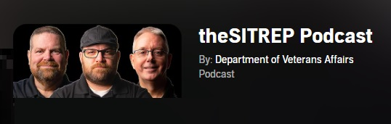

2025 Cost of Living Increase | How it Affects VA Disability & Social Security | COLA
In this episode of theSITREP, the host discusses the projected Cost-of-Living-Adjustment (COLA) for 2025 and how it will affect VA Disability and Social Security.
theSITREP Podcast

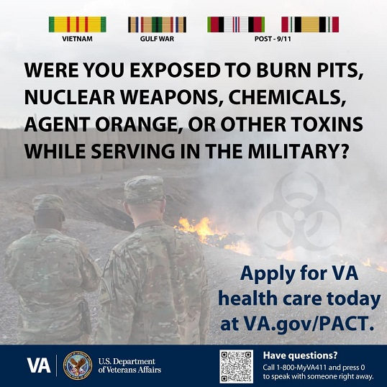



Featured Links

- National Parks Pass
- VALife Insurance
- VA Urgent Care Services
- Accessing Records from the National Archives or NPRC
- PACT Act Performance Dashboard
- How to Check Your PACT Act Claim Status
- Download VA Benefit Letters
- Podcasts on Veterans' Issues
- VA Health and Benefits Mobile App
- Women Veterans Call Center
- Veterans Legacy Memorial
- Million Veteran Program
- #VetResources

In The News

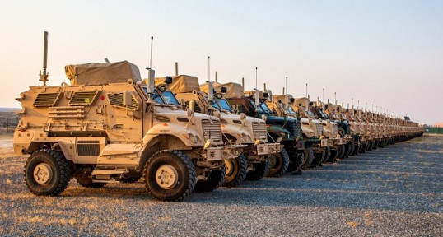

401 AFSB issues 38 MaxxPro MRAP vehicles from APS-5 in support of Operation Inherent Resolve
Joseph Kumzak | 401st AFSB | August 1, 2024

CAMP ARIFJAN, Kuwait -- The 44th Infantry Brigade Combat Team will receive 38 M1224 MaxxPro mine-resistant ambush protected vehicles to replace its current aging fleet operating in the U.S. Central Command theater.

The 38 armored fighting vehicles are being issued from Army Prepositioned Stocks-5 managed by the 401st Army Field Support Brigade.

Sgt. 1st Class Michael Bowers, 44th IBCT, S4 NCOIC, said the vehicles will be issued to multiple task forces throughout the region, and Soldiers with the 44th are looking forward to receiving the vehicles to bolster their tactical effectiveness.
Read Full Story

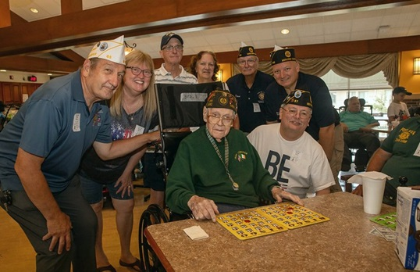

Menlo Park Veterans Home Treated to Bingo by Middlesex County American Legion Auxiliary
Jacob Turchi | TAPinto Edison | August 2, 2024

EDISON, NJ - Over 60 residents at the Menlo Park Veterans Memorial Home in Edison enjoyed playing Bingo on Saturday. The event was hosted by the Middlesex County American Legion Auxiliary and members of the Middlesex County American Legion.

Veterans and their spouses were treated to Bingo along with food from White Castle and Dunkin. Bingo prizes and food were all donated by the Middlesex County American Legion Auxiliary, according to a press release.
Read Full Story | View Images

Soldier Spotlight

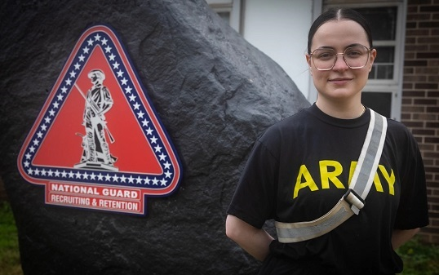

From a Father's Dying Wish to a Soldier's Dream: Bea Lujan's Journey to American Citizenship
SPC Seth Cohen | NJNG | August 4, 2024

The United States is a story of immigration. From the Mayflower, to Manifest Destiny, to the waves of immigrants in the late 19th century, to the stories of those who migrate from Latin America, each narrative is one of determination and resilience - just like Specialist Bea Lujan’s story.

Urged by her father’s dying wish, she made the unlikely journey across the Atlantic to become an American citizen.

Citizens like her define the United States and the US Army. With citizenship in hand, we can’t wait to see the amazing things she will accomplish.
Read Full Story

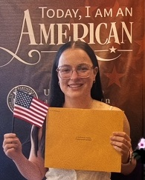

Never Forget

In Honor of all those from New Jersey who gave their lives in the fight against terrorism during Operation Enduring Freedom and Iraqi Freedom. In humble gratitude, we remember their sacrifice.

August 15, 2010
Operation Iraqi Freedom

SPC Jamal M. Rhett
U.S. Army
Palmyra, New Jersey
August 20, 2005
Operation Enduring Freedom

PO1 David M. Tapper
U.S. Navy
Atco, New Jersey

August 22, 2007
Operation Iraqi Freedom

SPC Michael A. Hook
U.S. Army
Little Egg Harbor, New Jersey
August 22, 2009
Operation Enduring Freedom

SSG Andrew T. Lobosco
U.S. Army
Somerville, New Jersey

"But on the battlefield their feet stood fast, and in an instant at the height of their fortune, they passed away from the scene, not of their fear, but of their glory."
~ Pericles
NJ Fallen Heroes Memorial

History

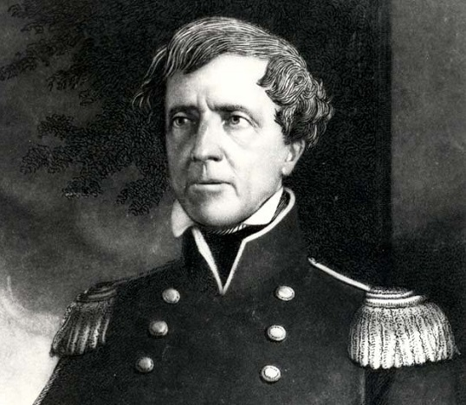
General Stephen Watts Kearny

August 14, 1861
As New Jersey’s response to the outbreak of the Civil War picked up in response to a third call for troops, the New York Times reported that “Camp Olden, so named after the respected and popular Governor of the State of New Jersey [Charles Olden], promises soon to be the arena once more of a fine body of troops, as the five regiments now called for by the Government will begin soon to muster at the camp.”

August 17, 1813
“Andruss’ detachment,” of militia companies from Hunterdon, Middlesex, Sussex, Monmouth and Essex Counties, left the New Jersey militia base at Paulus Hook en route to garrison Fort Richmond on Staten Island during the War of 1812. The militiamen remained on duty there through September 25.

August 17, 1917
Construction began on Camp Merritt, a Bergen County transit installation for soldiers on their way to France in World War I. More than one and a half million men moved through the camp, where they spent ten days prior to leaving for Hoboken to board ships for Europe. A similar number stopped there on the return from Europe in 1919.

August 18, 1846
Newark-born General Stephen Watts Kearny, one of America’s preeminent frontier soldiers and commander of the Mexican War “Army of the West,” a less than impressive collection of Missouri mounted volunteer units, the Mormon Battalion, and some artillery, stiffened by his own regular army dragoon regiment, captured Santa Fe, New Mexico without a shot being fired.

August 18, 1918
White soldiers from Mississippi marched into Bergen County’s Camp Merritt integrated YMCA building and forcibly ejected five black soldiers. Black soldiers who gathered to protest the ejection then faced off against a group of Southern white troops. Rumors of razor fights and other atrocities spread on both sides and as the situation verged on a full scale riot, Military Police moved in and broke up the hostile crowds with swinging nightsticks. Several shots were fired in the course of the ensuing melee. Two black soldiers were wounded and a third, Private Edward Frye of Kentucky, who was not involved in the disturbance and was sitting in his barracks, was killed when a stray bullet hit him in the chest.

Resources

  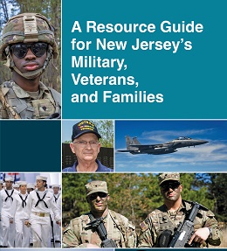
  

  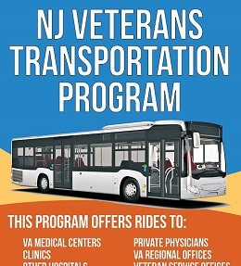
  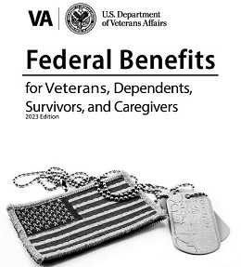

DMAVA Careers

We Are Hiring!
At the New Jersey Department of Military and Veterans Affairs we take our work in support of Veterans, Servicemembers and their families very seriously. Whether supporting our Veterans with nursing care, transitional housing, or assisting them in navigating access to their Veteran benefits, the Department provides valuable services and can offer rewarding career opportunities to members of the public.
We also have opportunities in facilities management and program management. In addition, we have job openings for members of our military to serve in AGR and Federal Technician roles.
Subscribe to DMAVA Jobs Bulletin to stay updated on job openings.
Vacancies

Stay Connected


Click Here

We hope you enjoy receiving our newsletter and find it both educational and engaging. If you have questions about our department, our programs or your benefits, please visit our website at nj.gov/military to get contact information.
Contact DMAVA

Please email us at outreach@dmava.nj.gov with feedback and comments regarding the newsletter. If you would like to contribute with an item of interest to our subscribers, please email us your proposal.
Visit the DMAVA archives to view previous editions of our newsletter.

Forward to a friend
Subscribe

 |  |  |  |  | 

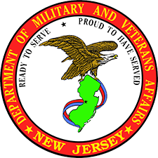
nj.gov/military
NJ Department of Military & Veterans Affairs
101 Eggerts Crossing Road
Lawrenceville, NJ 08648
Unsubscribe | Privacy Notice

Disclaimer: The appearance of any non-DMAVA information or hyperlinks does not constitute endorsement of the products or services on the part of the New Jersey Department of Military & Veterans Affairs.

